|  |  |
| --- | --- |
| ***ROLL NO*** | ***22SW040*** |
| ***NAME*** | ***FAROOQUE SAJJAD*** |
| ***SUBJECT*** | ***CN PRACTICAL (LAB_01)*** |
| ***TEACHER*** | ***MA’AM AISHA*** |

***CLASS WORK***

***Question 1: If I want to change the module, what are necessary steps to be done first?***

* *First, power off the device to avoid hardware damage.*
* *Remove the current module carefully.*
* *Insert the new module into the slot, ensuring it’s properly aligned.*
* *Power on the device and verify the module is recognized by checking its status in Packet Tracer.*

***Question 2: How does a switch build its MAC table? Justify answer with example.***

* *A switch builds its MAC table by learning the source MAC addresses of incoming packets.*
* *When a packet arrives on a switch port, it records the MAC address and associates it with that port.*
* *For example, if PC1 with MAC address “AA:BB:CC:DD:EE:01” sends data through Port 1, the switch adds `AA:BB:CC:DD:EE:01` to its table with Port 1 as its location.*

***Question 3: How to check connectivity among end devices in RealTime Mode and Simulation Mode in Cisco Packet Tracer?***

* ***Real-time Mode:*** *Simply send a ping between devices using the Command Prompt on a PC. Successful replies confirm connectivity.*
* ***Simulation Mode:*** *Add a Simple PDU (envelope icon) from one device to another and watch the packet flow step by step to verify if it reaches the destination.*

***LAB TASKS***

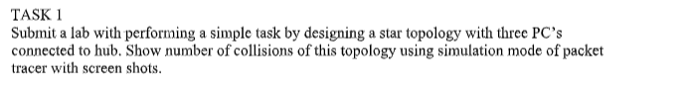

***First Setting up the envirnment***

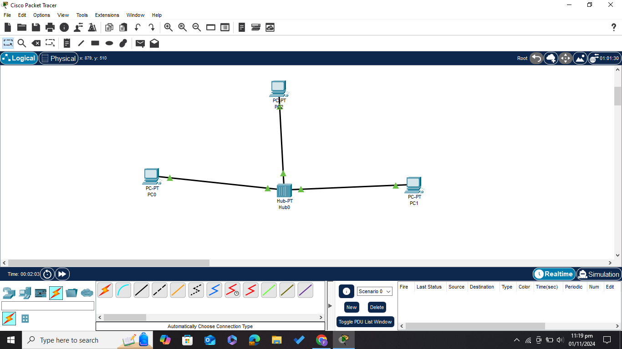

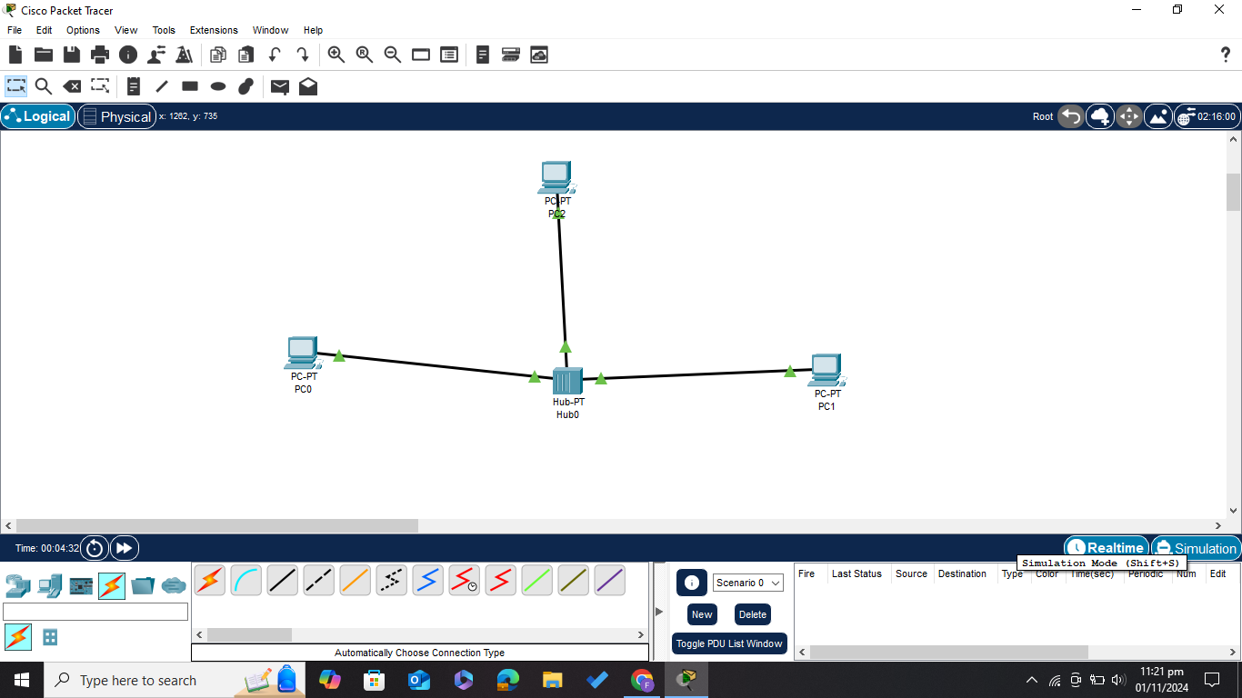

***Assigning IP addresses to PCS***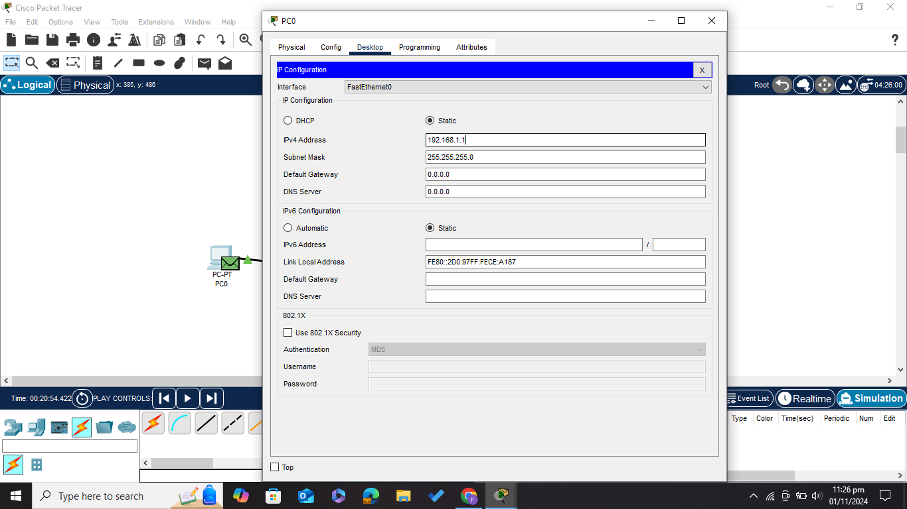

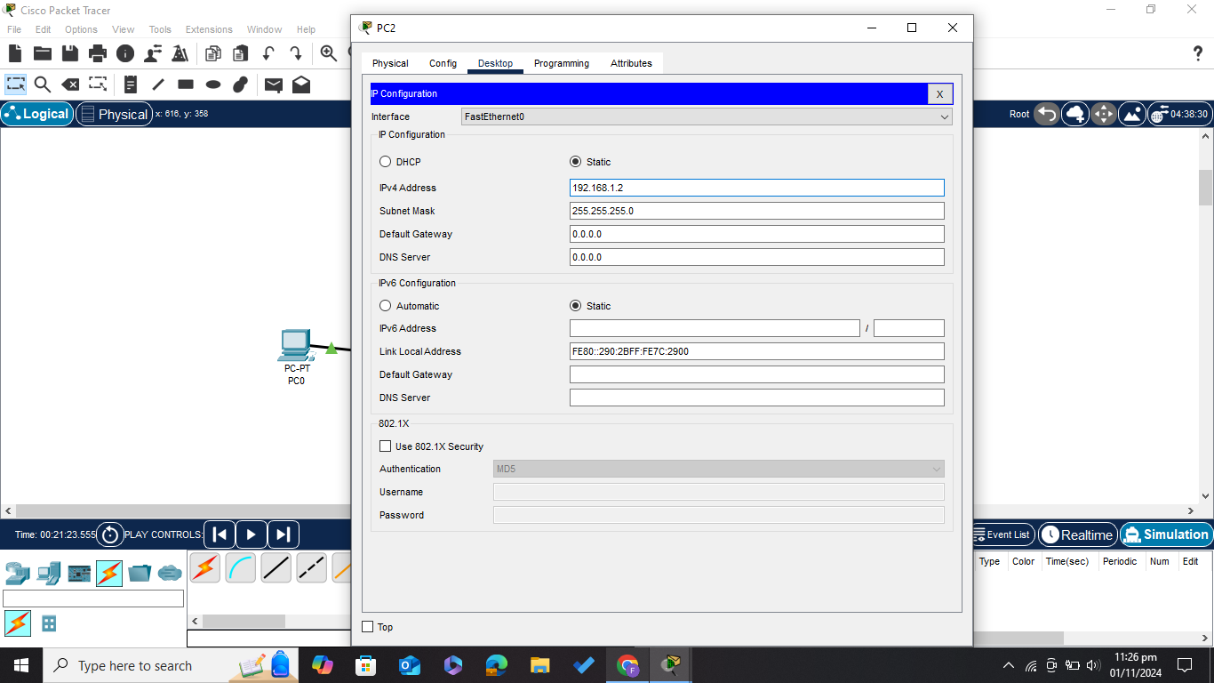

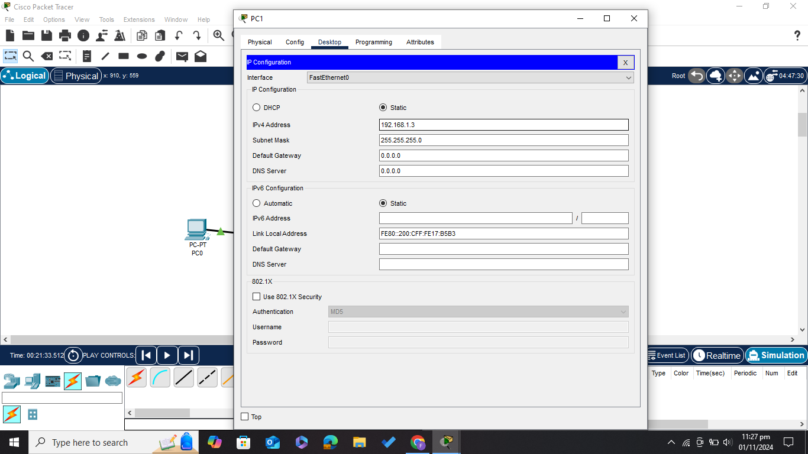

***Enabling Simulation Mode in Packet Tracer***

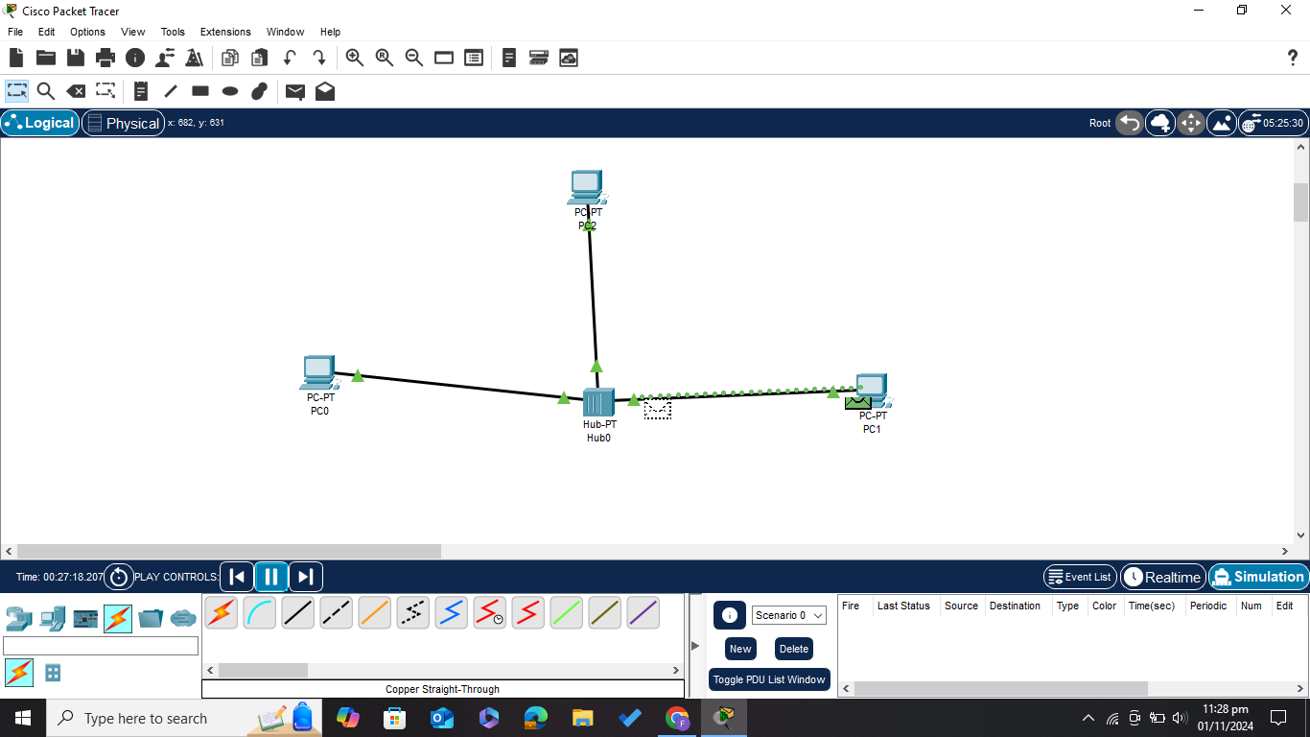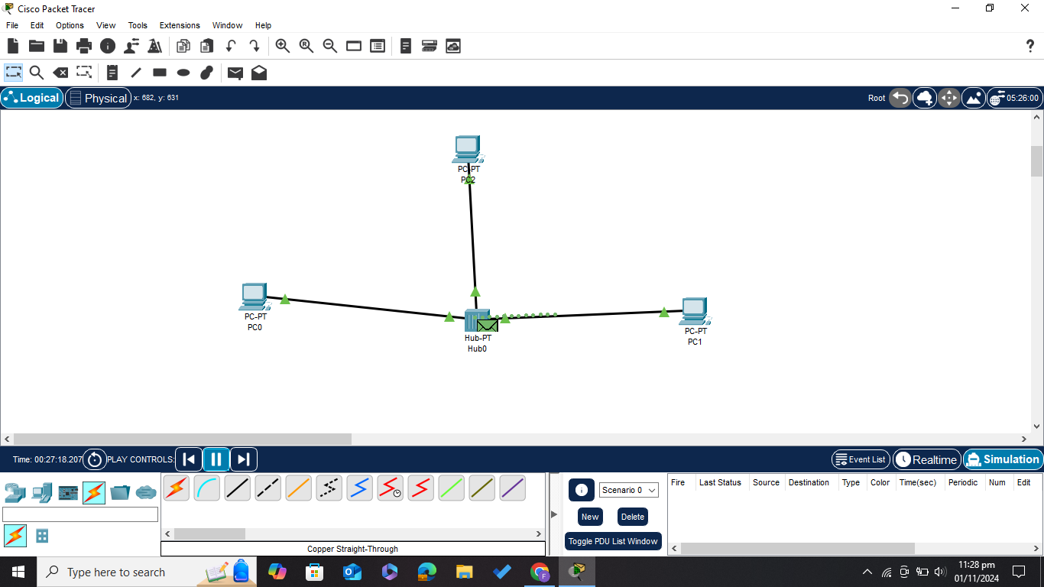

***For Showing Collisions Adding a simple PDU from PC0 to PC1 and from PC2 to PC1***

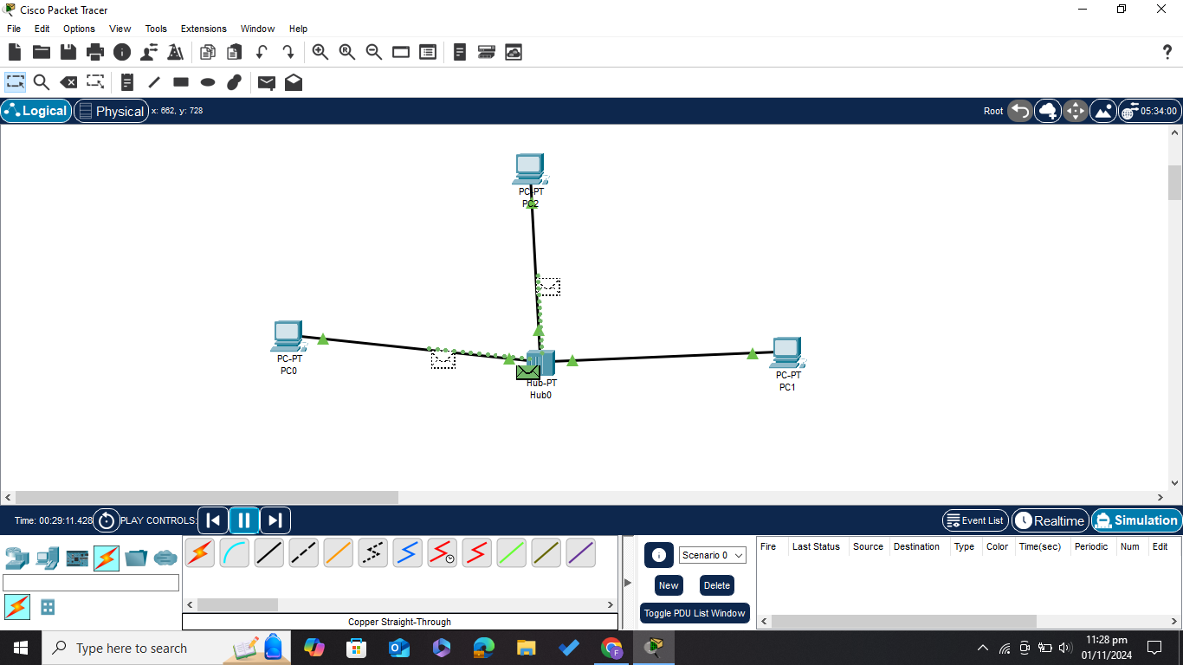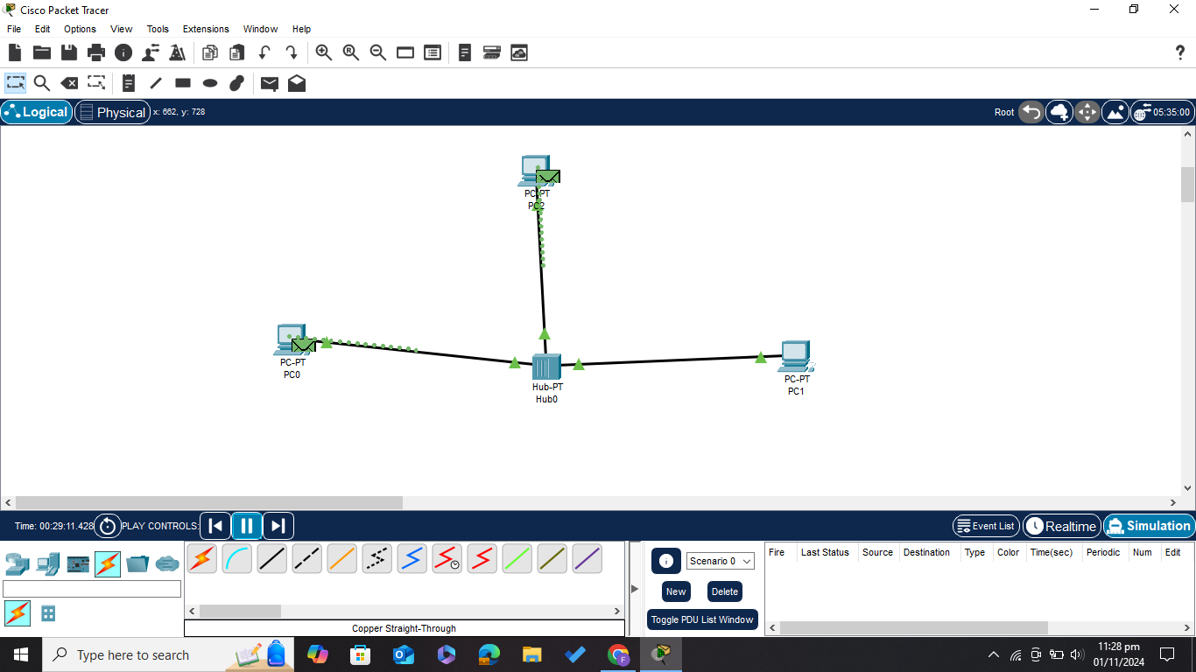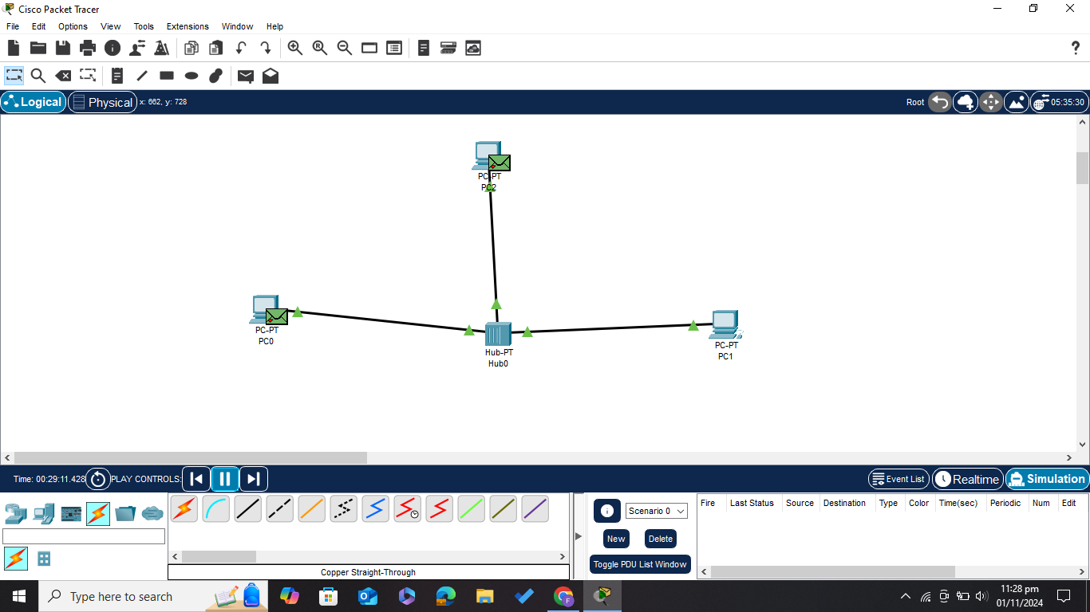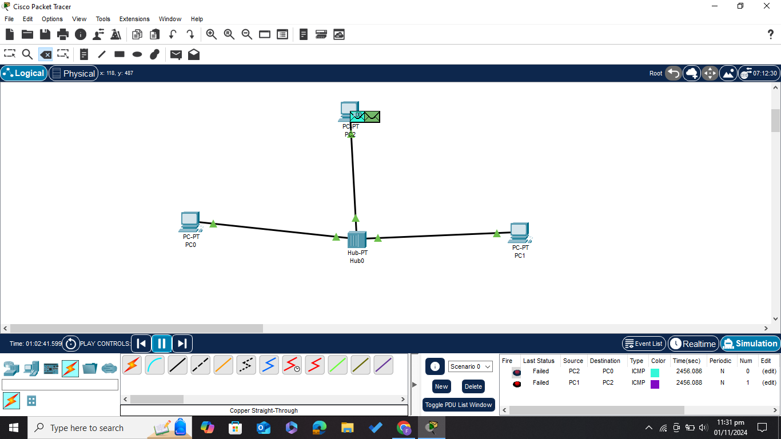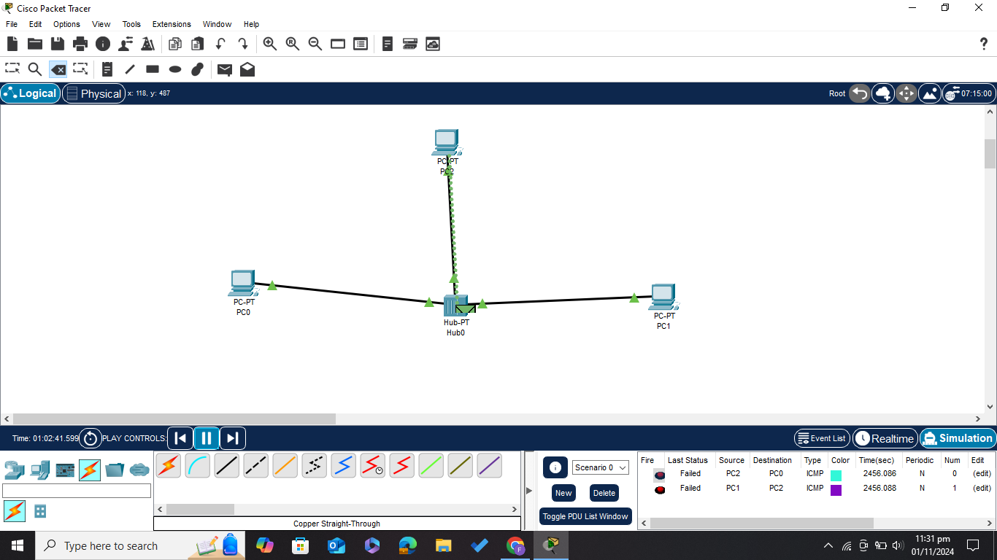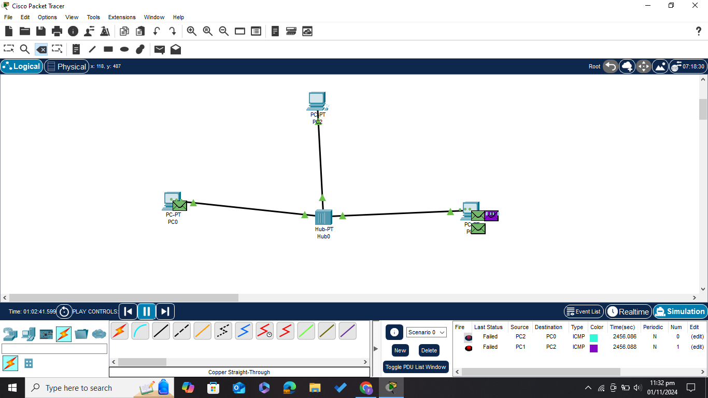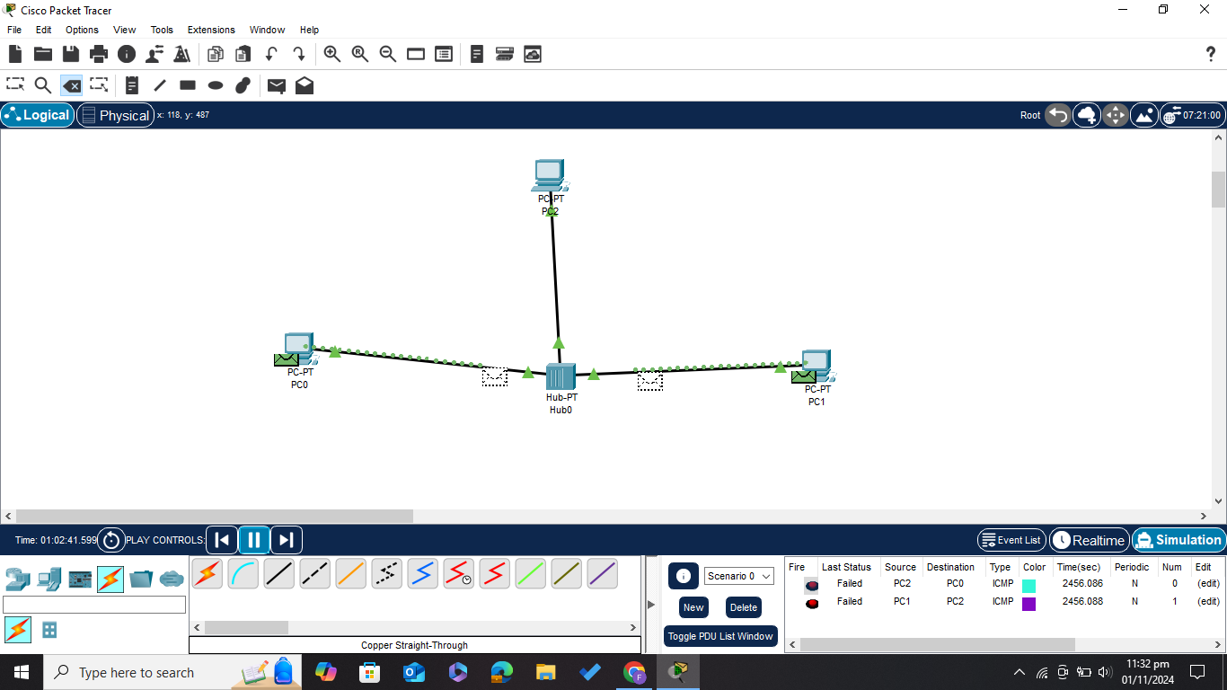

***Here the Collision Occurs***

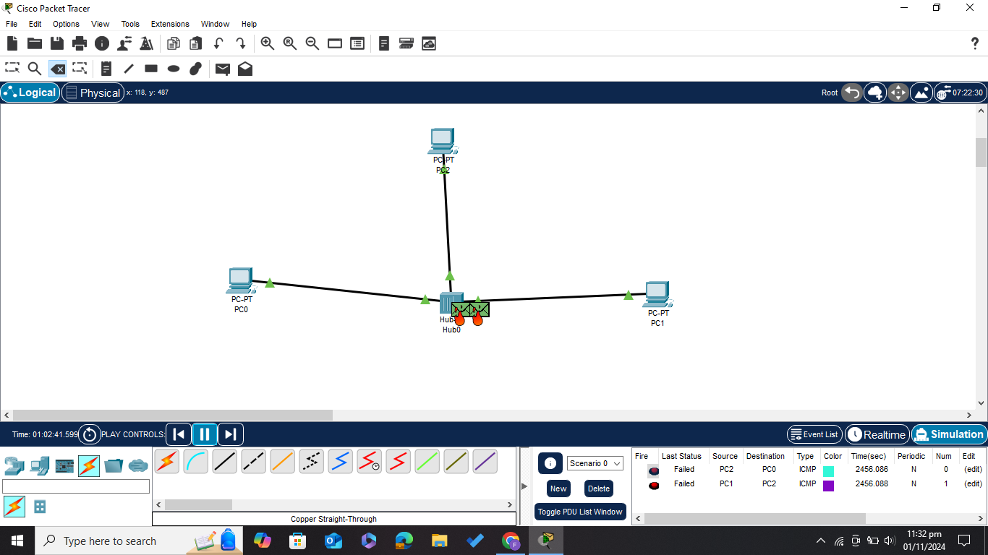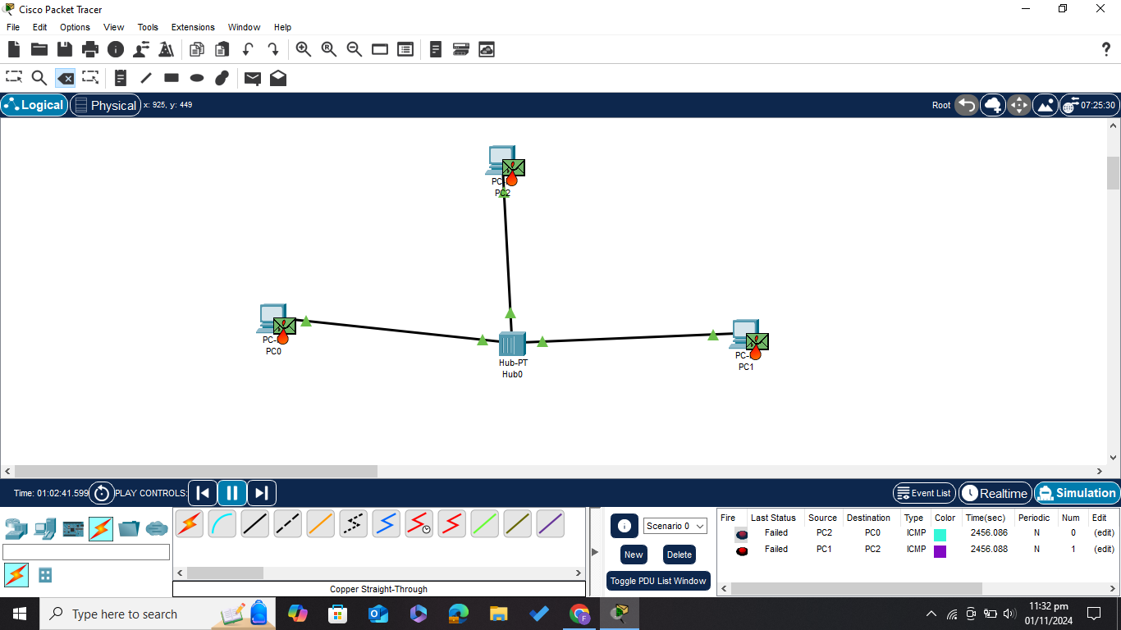

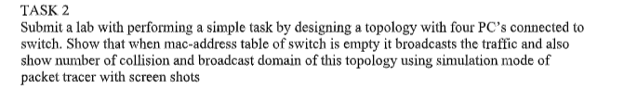

***First Setting Up the Environment***

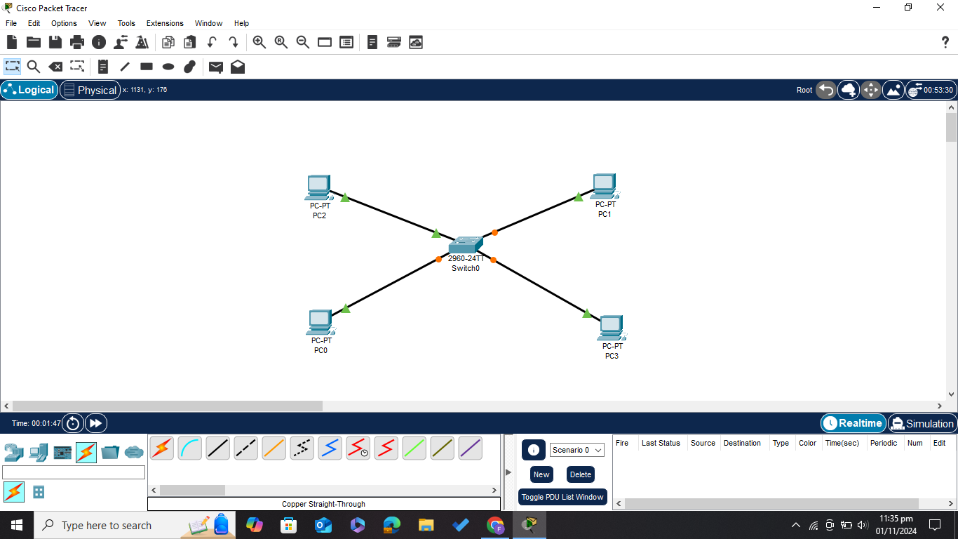

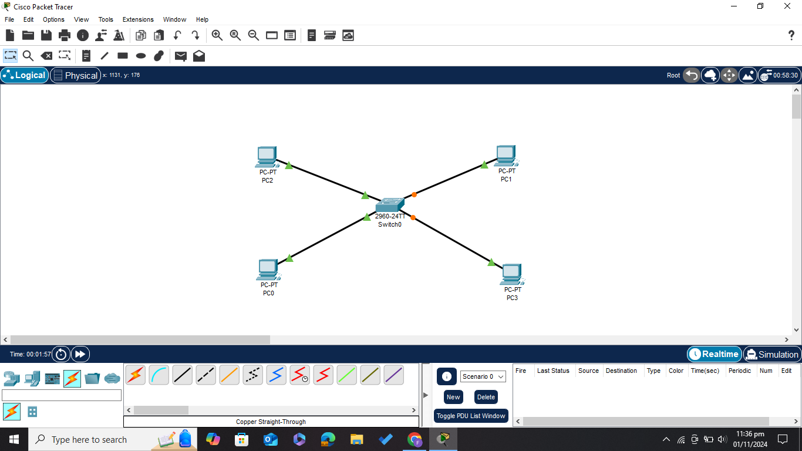

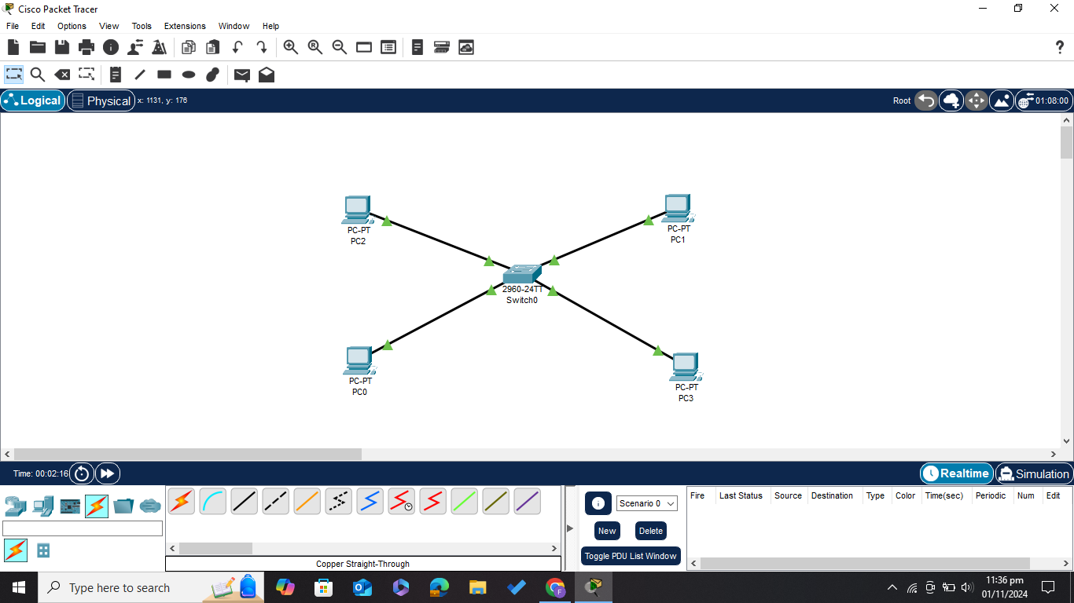

***Assigning IP addresses to all the PCS***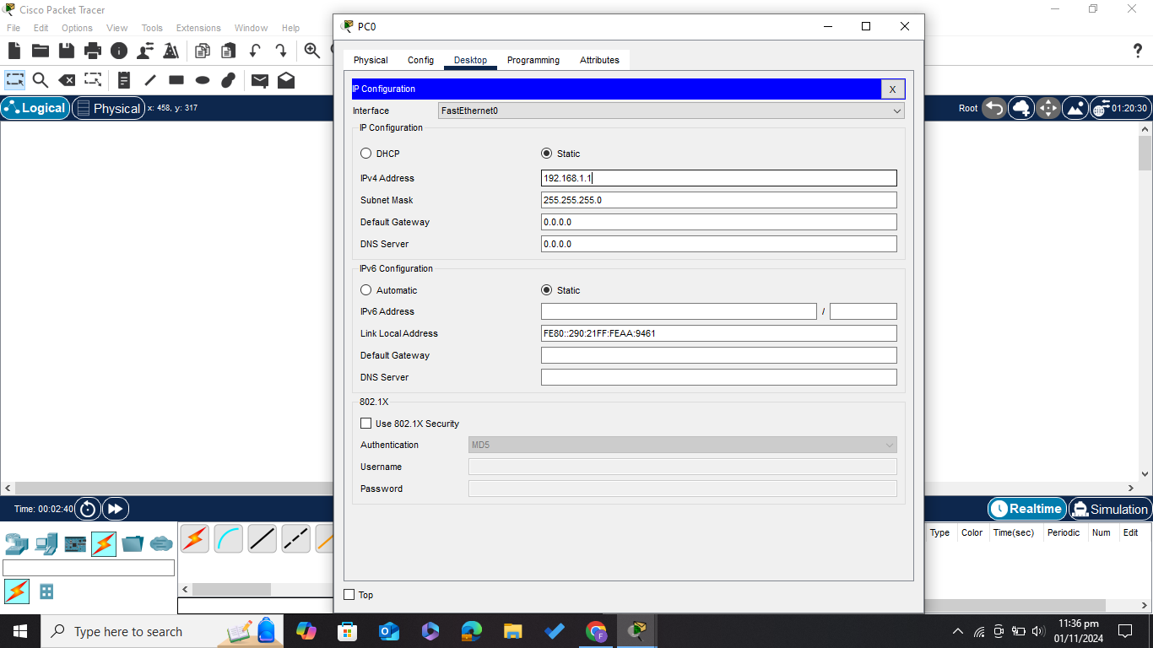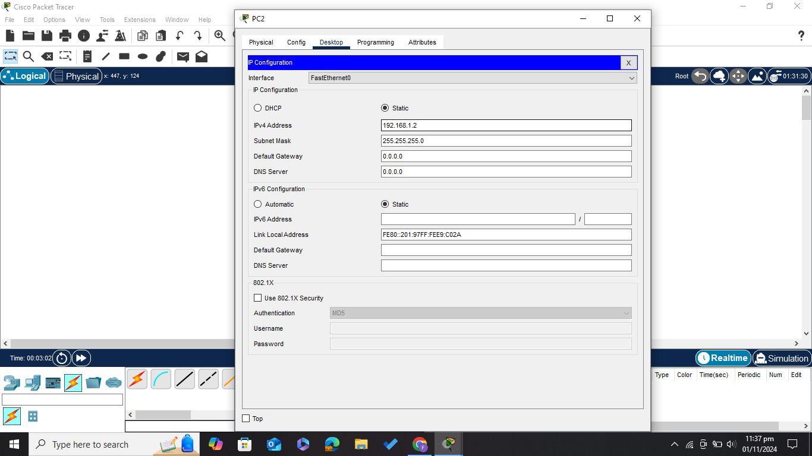

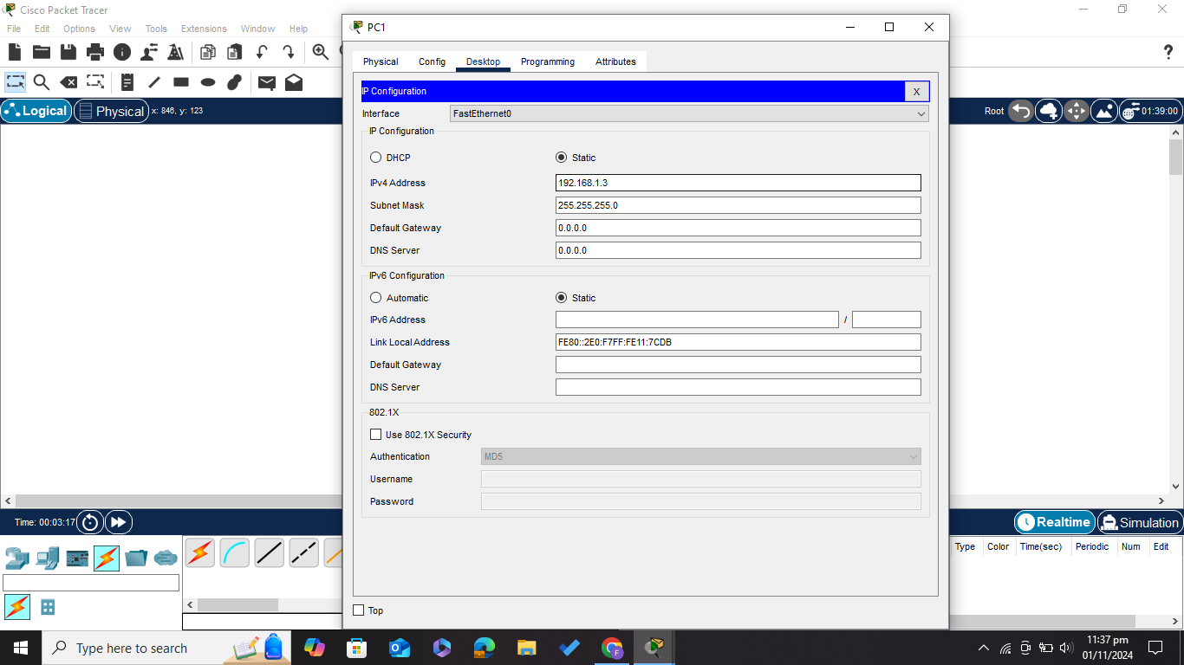

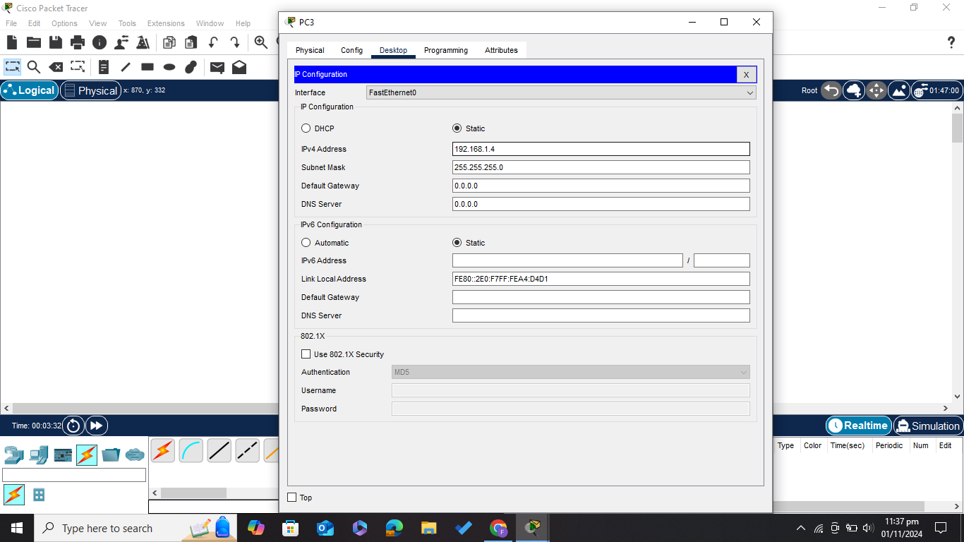

***Enabling Simulation Mode in PKT***

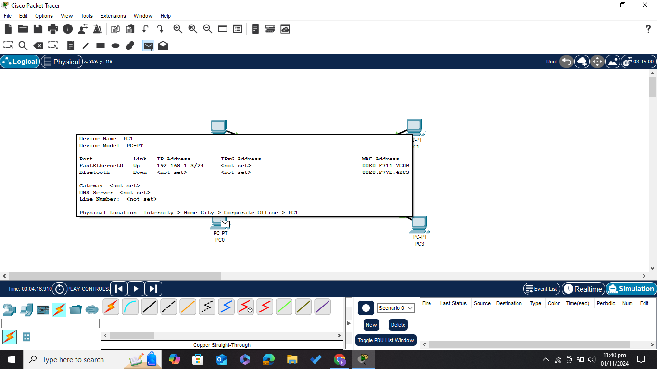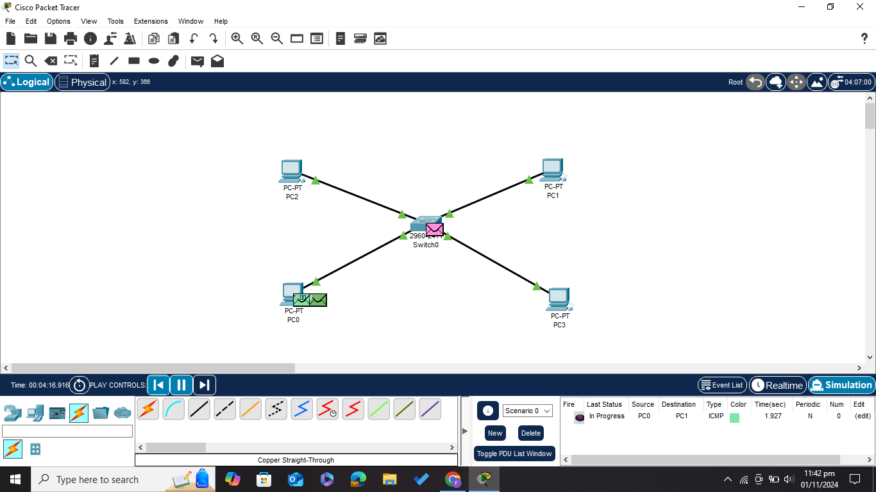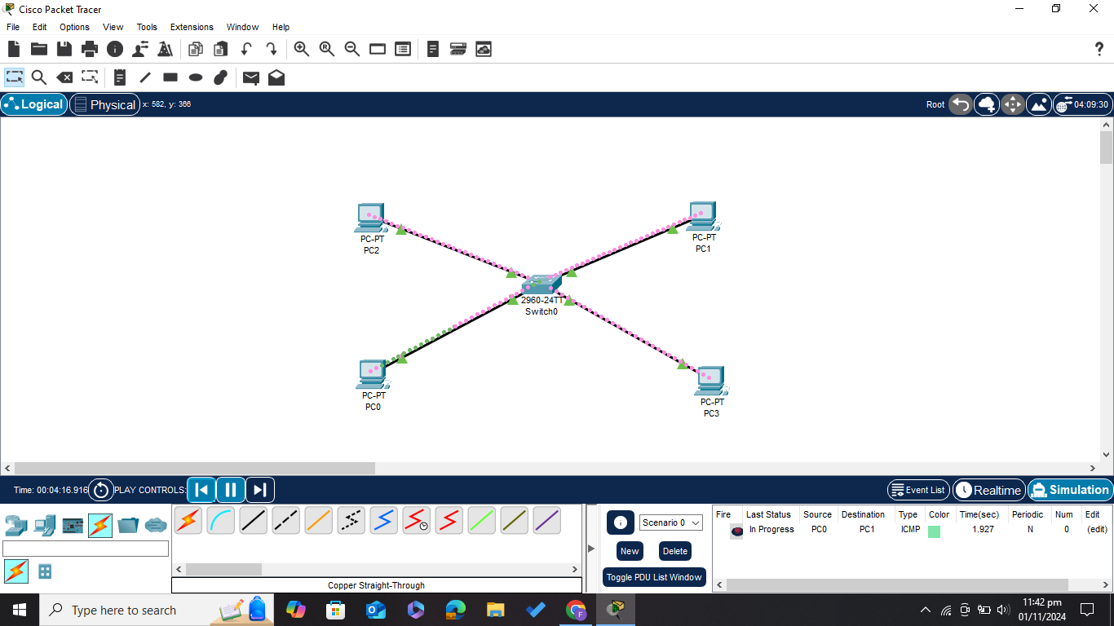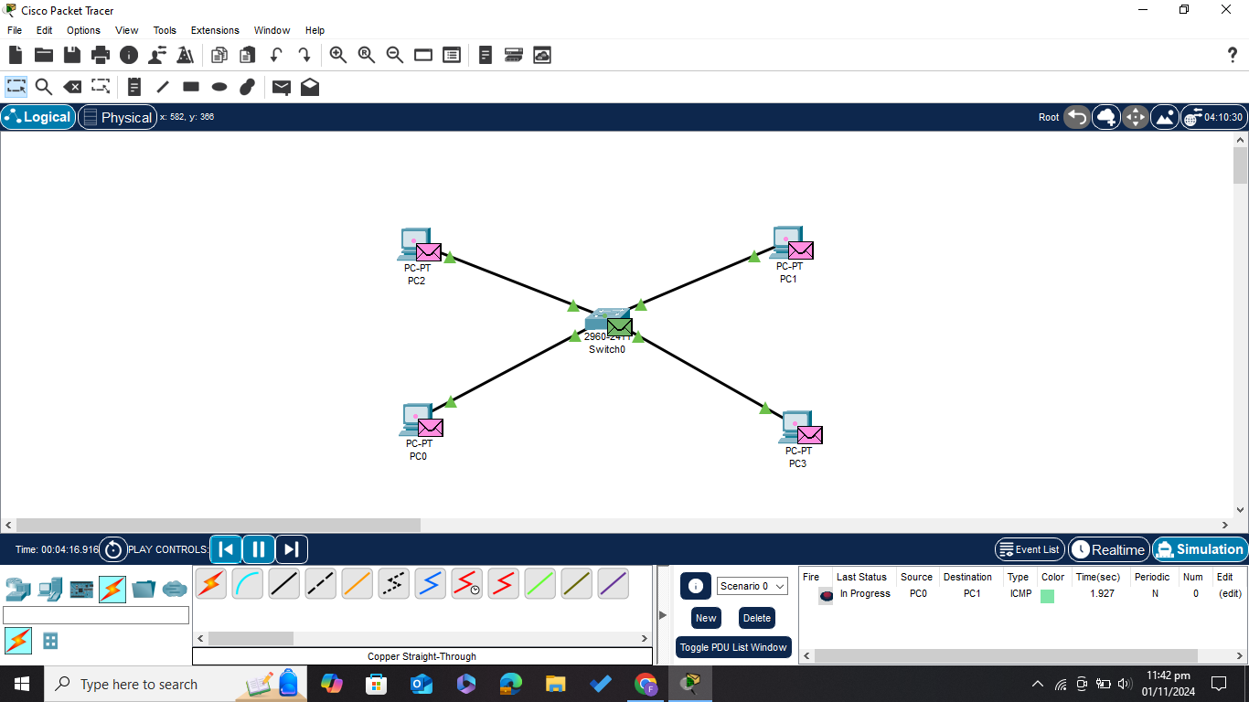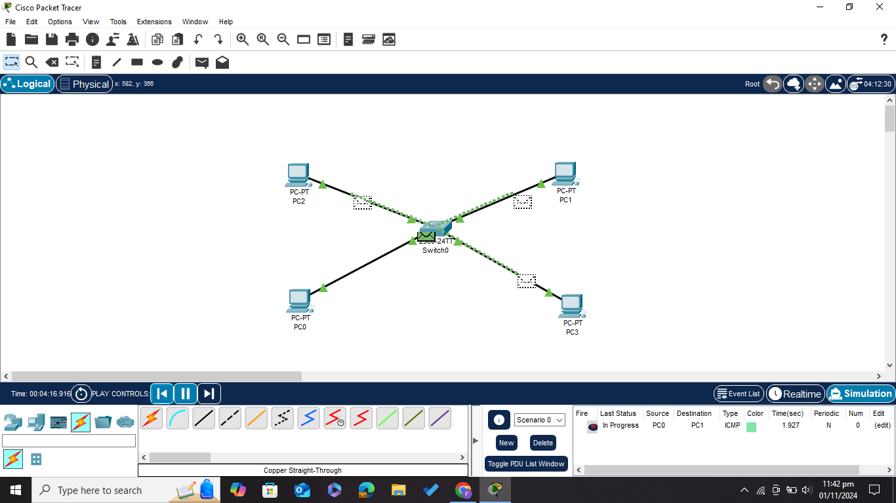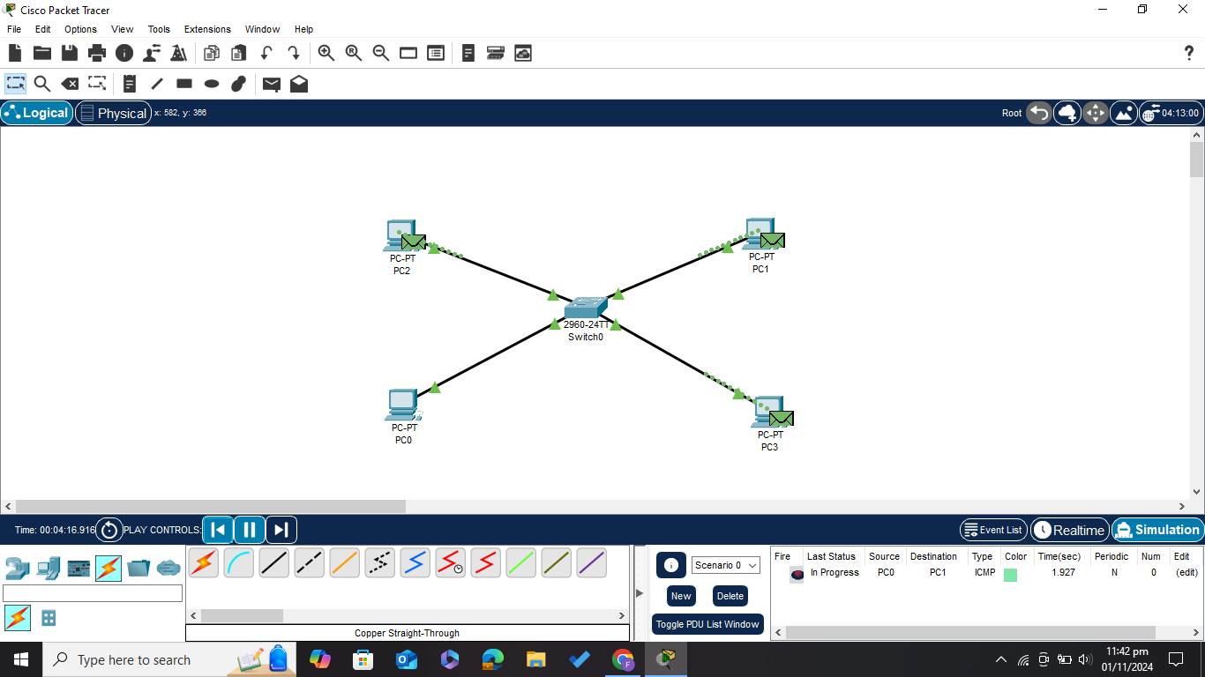

***Note***

***There are* ***no collisions*** *because each PC has its own collision domain when connected to a switch.***

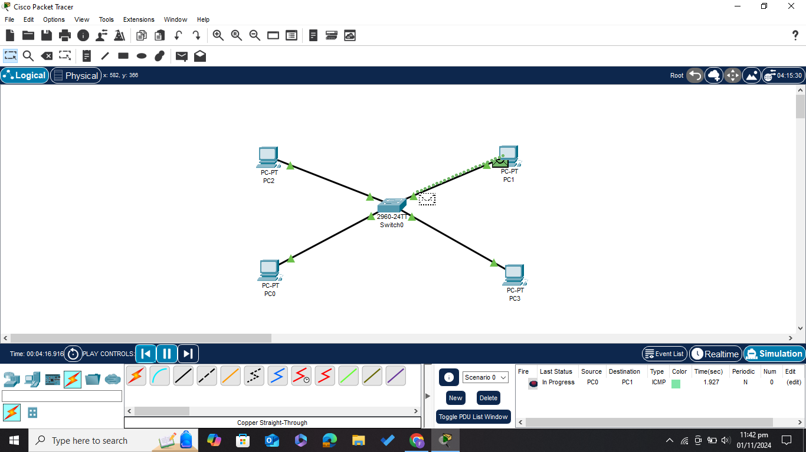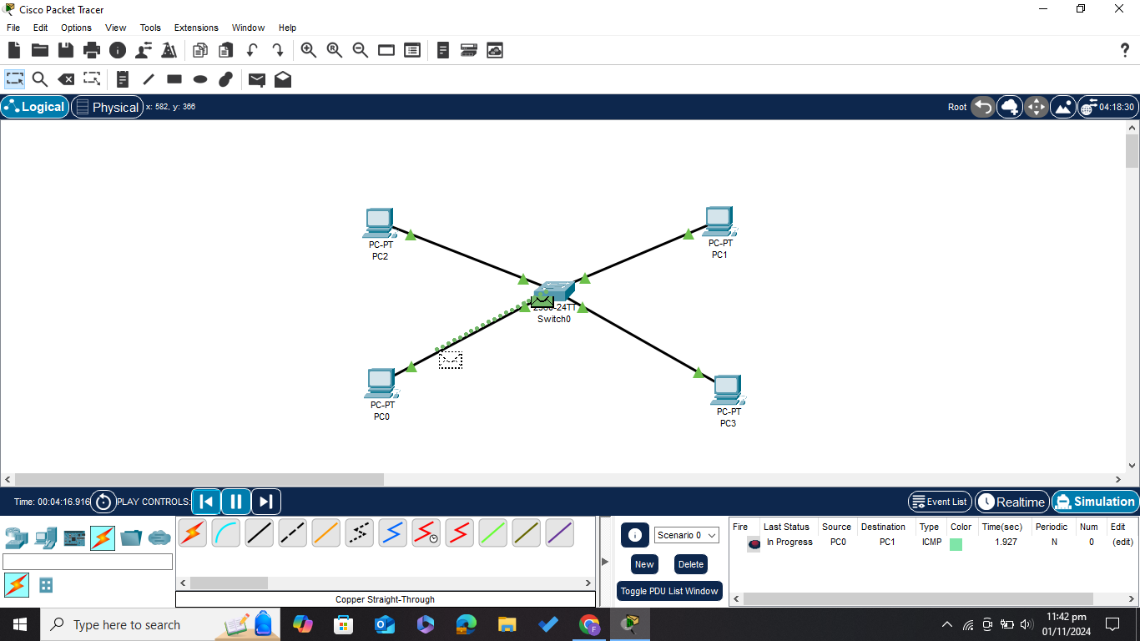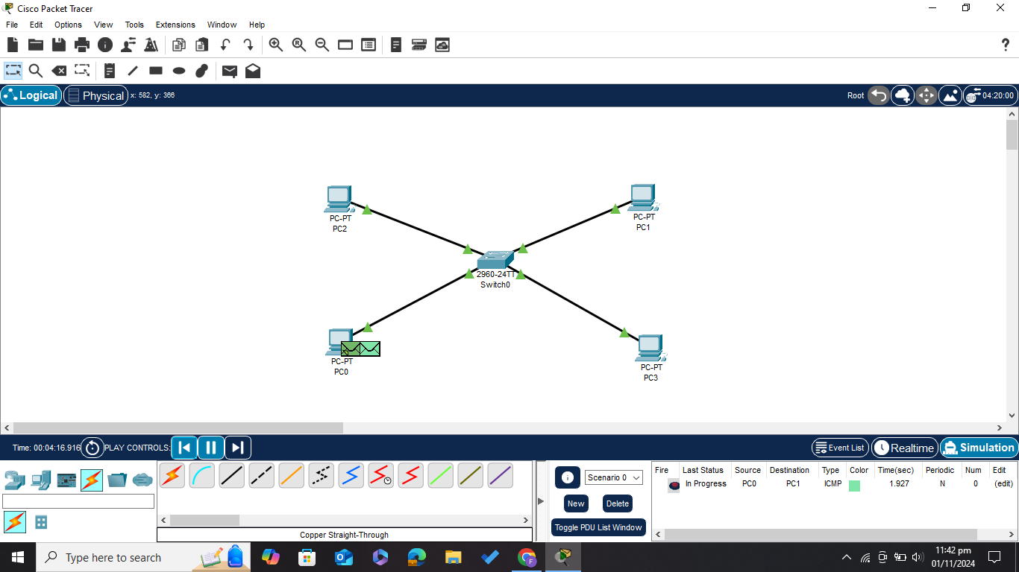

***NOTE***

***There is only* ***one broadcast domain*** *across the entire network setup.***

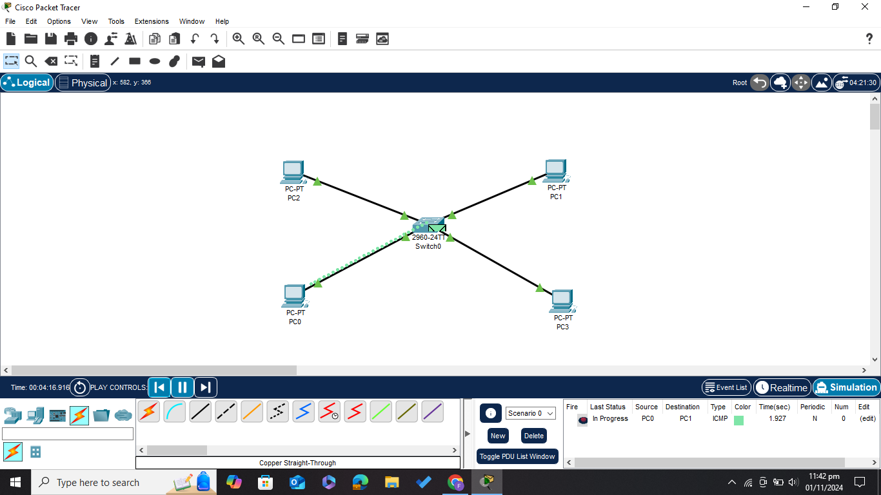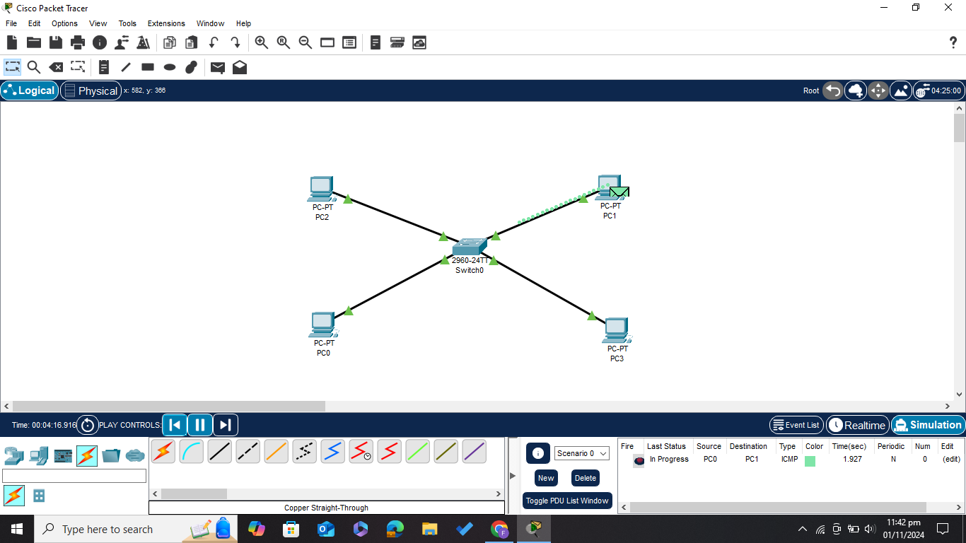

***After Broadcasting Switch has learned the MAC addresses of all the PCS and store it in it’s table***

